Nahrin Sharna

Professor Robert Mann

CIS 200-L

01/19/2019

Lab 01

**Task 1:**

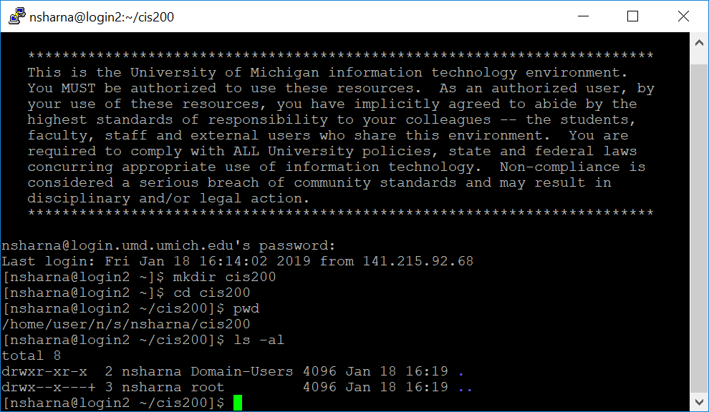

**Task 2:**

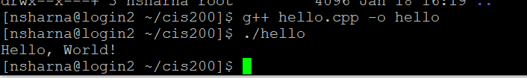

**Task 3:**

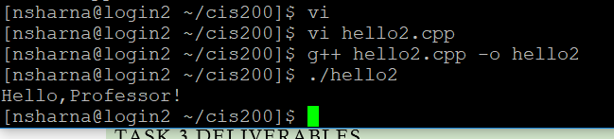

**Task 4:**

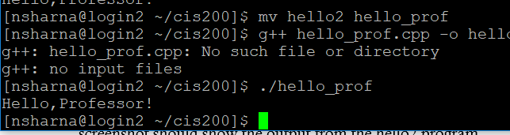

**Task 5:**

Screenshot of cis200 directory:

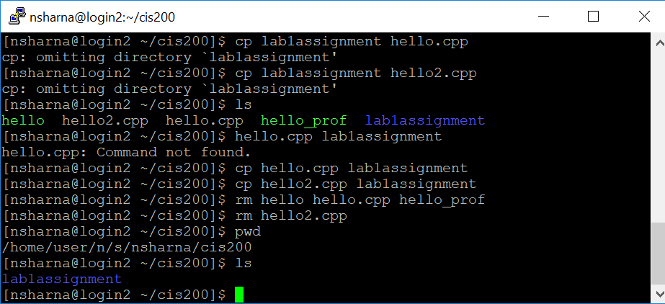

Screenshot of lab1assignment directory:

